**Leader Overview**



**Volume Overview**

**Be Different**

*Christians have long understood that we live and walk a fine line. We are to be in the world—all things to all people, as Paul put it—yet not of the world. God’s people have always been a chosen people, holy and set apart from the world’s ways. To pull it off, to be truly different, means we must each hold fast to the truth, speaking it when needed, all while humbling ourself and faithfully serving others.*

**Session Overview**

**Speak Truth**

*In this* **Live** *session, kids will discover the importance of speaking the truth. Paul and Barnabas show us that once we know God’s truth, we have a responsibility to share it. When we confront the world’s lies with God’s truth, others have an opportunity to hear that truth.*

**Bible Lesson**

Paul and Barnabas Confront Falsehood

[Acts 14:8–20](https://ref.ly/logosref/Bible.Ac14.8-20)

**Faith Fact**

I will speak the truth.

**Faith Verse**

[Romans 12:2](https://ref.ly/logosref/Bible.Ro12.2) (NLT)

Don’t copy the behavior and customs of this world, but let God transform you into a new person by changing the way you think.

**Preparing for the Session**

**Leader Preparation Time: 20–25 Minutes**

|  |
| --- |
| ***You Will Need***  ***Large Group***  *• Bible*  *• Worship songs (Song suggestions: “How I Praise” (Lyric Video) by Planetshakers; “I Thank God” (Lyric Video) by Maverick City Music; “Build My Life” (Lyric Video) by Housefires; “Available” (Lyric Video) by Elevation Worship)*  *• For groups not using a phone or tablet only, add:*  *• Projector or TV*  *• Laptop*  *•* ***Faith Fact Slide***  *•* ***Faith Verse Video*** *or* ***Slide***  *•* ***Bible Lesson Video***  *•* ***Teaching Point Slides 1–3***  *• Coin*  ***Small Group***  *• Bibles for kids in the group to share*  *•* ***Small Group Faith Verse Review Page****, one set per team*  *• Scissors*  *• Optional: Smartphone to time activity*  *•* ***Small Group Activity Page****, one per kid*  *•* ***Small Group Activity Page Answer Page***  *• Pencils or pens, one per kid*  *• Crayons or markers*  *To access session content and videos from a computer, visit:* [***BibleEngagementProject.com/downloads***](https://bibleengagementproject.com/downloads) |
| ***Getting Ready***  ***Large Group***  *• Download videos and slides if needed.*  *• Select worship song(s) and have them ready to play.*  *• Read the Bible Lesson Scripture to prepare for Teaching Time.*  *Small Group*  *• Print copies of the* ***Small Group Faith Verse Review Page****, one set per team.*  *• Cut apart the slips from the* ***Small Group Faith Verse Review Page****.*  *• Print copies of the* ***Small Group Activity Page****, one per kid.*  *• Print the* ***Small Group Activity Page Answer Page*** *if needed.*  ***First time leading* Live *for Kids? Check out the*** [**Facilitator Guide**](https://0b769b0ed3569ef9d18b-f88d8272f61086866d50d048b43ef630.ssl.cf2.rackcdn.com/sites/biblengagementproject/Listen_Facilitator_Guide.pdf)**.** |

**Large Group**

**30 Minutes**

*See what’s needed at the beginning of the session.*

**Introduction**

Hello, everyone! I’m thrilled that we get to spend some time together today. We’ve been talking about how Christians are called to be different from the rest of the world. As we get closer to God, we can stand out in the most amazing and powerful ways! Raise your hand if you want to be a standout person. *(Group response)* I thought so!

Today our Bible story is about two men named Paul and Barnabas. They knew truth that the people around them didn’t know. And if they shared that truth, they might be in danger! So they had to choose: Would they speak the truth or not? Has there ever been a time when you thought it might be easier not to tell the truth? *(Group response)*

• *Share a relatable, personal story about a time you had to choose whether to tell the truth.*

Sometimes we think hiding the truth or lying might be easier than speaking up. Usually, we’re worried about how others will react. *What if we get in trouble? What if people think less of us?* But it’s always best to speak the truth, even when it isn’t easy.

**Faith Fact**

Telling the truth isn’t always easy, but it’s something we *can* do with God’s help. That’s what our Faith Fact is all about. **I will speak the truth.** God expects His people to speak the truth. It’s one of the things that makes us different from people in the world who think lying isn’t a big deal. Speaking the truth—even when we’re nervous or scared about what might happen—is always the best choice.

• *Show the* ***Faith Fact Slide.***

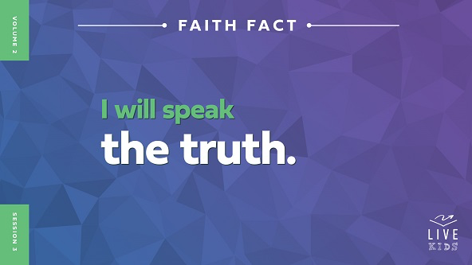

Let’s say the Faith Fact together. **I will speak the truth.** This time, point to yourself when you say, “I” and point to your mouth when you say, “speak.” **I will speak the truth.** One more time! **I will speak the truth.**

**Game**

**Heads or Tails**

|  |
| --- |
| ***You Will Need***  *• Coin*  *No prep is needed for this activity.* |

Now it’s time for a game! How many of you are really good guessers? *(Group response)* Well, now’s your chance to put that to the test! We’re going to play a game called Heads or Tails.

Here’s how it works. I’m going to flip a coin, but first everyone in the room will guess whether it will land heads up or tails up. If you think it will be heads, put your hands on your head. If you think tails, put your hands behind your back. If you guess right, you get to keep playing. But if you guess wrong, you have to sit down. The last person standing wins. Ready? Let’s play.

• *Repeat flipping the coin until someone wins.*

• *Play again if time allows.*

Great guesses, everyone! You know, sometimes in games like this it can be tempting to lie about how we did. It’s pretty easy when everyone is playing at the start of the game. If you guessed wrong, you might have been tempted to pretend you got it right, so you could stay in the game. But that’s not fair, is it? *(Group response)* When we play honestly and speak the truth, the game is better for everyone!

God wants us to speak the truth—not just when we’re playing games but in every area of life. Yes, it might not always be fun or easy. But when we choose to speak the truth, we are living in the amazing, different way that makes us stand out for God. As a reminder to do that, let’s say the Faith Fact together. **I will speak the truth.**

**Worship**

God *always* speaks the truth. I’m so thankful for that! As we worship today, let’s remember how truthful God is. Who’s ready to worship Him? *(Group response)* Great! Let’s worship Him together by singing.

• *Lead the kids in singing one or two praise songs. See suggestions at the beginning of the session.*

**Bible Lesson**

Thanks for singing and worshipping God with me, everyone! When we sing the truth about God, His truth sticks in our mind and heart. And it changes the way we think and act. Let’s pray.

**Prayer**

|  |
| --- |
| *Dear God, thank You for telling us the truth in Your Word. Help us learn from it today, so we can be who You want us to be and do what You want us to do. We love You. In Jesus’ name. Amen.* |

**Video Intro**

When we get into our Bible story in a few minutes, we’ll see if Paul and Barnabas decided to speak God’s truth or not. But first let’s watch this video and check in with Dash.

• *Play* ***Bible Lesson Video****.*

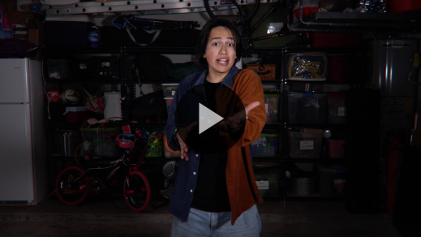

**Bible Story**

**Paul and Barnabas Confront Falsehood**

Dash did the right thing by telling the truth, even though it might have seemed easier not to say anything at all! We all face situations like that—and so did the people in the Bible. But we can trust God’s Word. It’s 100 percent true, and it helps us know how to follow God in any kind of situation. Let’s dive into it now!

**Teaching Time**

In today’s Bible story, Paul and Barnabas were doing their best to share the good news of Jesus with everyone. But after a miracle that showed God’s power, the people responded in a surprising way. We’ll talk more about that in a minute. Paul and Barnabas realized speaking the truth was going to be dangerous. And they had to decide what to do.

Why do you think it can be hard to tell the truth sometimes? *(Allow responses.)* It’s important to remember that speaking the truth is always the best choice. That’s what our Faith Fact is all about. Let’s say it together. **I will speak the truth.**

Let’s look at what happened to Paul and Barnabas. Grab your Bible or pull up a Bible app on your device. Turn to [Acts 14:8–20](https://ref.ly/logosref/Bible.Ac14.8-20).

• *In order to keep Large Group time moving along, we recommend that the leader reads the Scripture portions aloud.*

• *Optional: Remind the kids to mark this place with a bookmark, so they can read it on their own at home.*

**1. People thought Paul and Barnabas were gods.**

• *Show the* ***Teaching Point 1 Slide.***

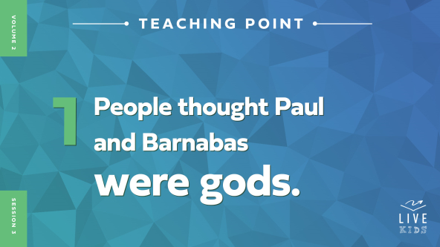

• *Read* [*Acts 14:8–13*](https://ref.ly/logosref/Bible.Ac14.8-13)*.*

Paul and Barnabas were on mission to share the good news of Jesus with everyone. One day, a man who couldn’t walk was listening to their preaching. Paul could see the man was full of faith, so he called for the man to stand up. And God healed him! Suddenly, the man could walk even though he had never *ever* walked before. What an awesome miracle!

Of course, the people who saw this were amazed! Believe it or not, they were so amazed that they thought Paul and Barnabas were gods. Why do you think they thought this? *(Allow responses.)* Remember, most of these people didn’t know anything about Jesus or the one true God. They worshipped idols or statues that they called gods. And they thought Paul and Barnabas were those fake gods in human form. The people were so amazed by the miracle that this was the only explanation that made sense to them.

This idea might sound super weird to us, but let’s try to look at it from their point of view. How many of you like superheroes? *(Group response)* If you have a favorite superhero, shout out his or her name. *(Group response)* We know superheroes aren’t real, but we watch movies and read comic books about them. We play with their toys or games and buy stuff that has their picture on it.

Now imagine you saw someone flying over a row of cars. What’s the first thing you’d think? *(Allow responses.)* That person must be a superhero! But instead, they might just be wearing a jetpack to help them fly. You might have thought they had special powers, but really the jetpack gave them the ability to fly. In the miracle Paul was a part of, Paul didn’t have special powers. It was our God who had the real power to heal the man who was lame.

So Paul and Barnabas had to choose. Would they ignore what the people were saying? Would they accept the people’s praise? Or would they speak the truth? Raise your hand if you think it would have been hard for Paul and Barnabas to tell the truth. *(Group response)* Raise your hand if you think it would have been easy. *(Group response)*

**2. Paul and Barnabas spoke the truth.**

• *Show the* ***Teaching Point 2 Slide.***

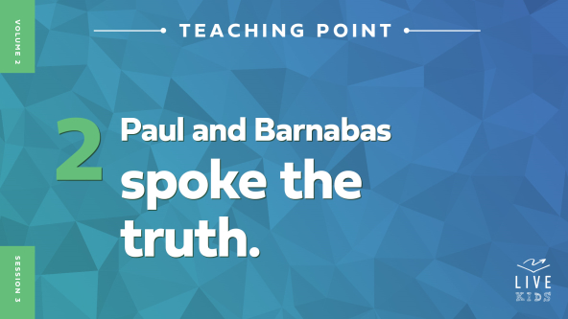

• *Read* [*Acts 14:14–18*](https://ref.ly/logosref/Bible.Ac14.14-18)*.*

How did Paul and Barnabas react when they heard the people were about to start worshipping them instead of God? *(Allow responses.)* They were super upset! Paul and Barnabas tried to tell the crowd that they were just normal people and it was God who made the miracle happen. But the people barely listened and still wanted to worship them!

Why do you think it was so hard to get the crowd to believe the truth? *(Allow responses.)* If you had never heard of God and the miracles He can do, it might be easy to think your imaginary gods did the cool thing you saw, right? *(Group response)*

Even though the crowd didn’t believe what they were saying, Paul and Barnabas still spoke the truth. But it probably wasn’t easy. I need a volunteer to come up and help me with this next part.

• *Invite a girl to join you up front.*

Let’s pretend that *(name of girl volunteer)* came with a bunch of cupcakes for everyone today. Now *(name of boy)* had actually made the cupcakes. But there were so many cupcakes that *(name of boy)* needed help carrying them in. So *(girl volunteer)* offered to help.

What if I saw *(girl volunteer)* with the cupcakes? And I began praising her and giving her all kinds of gifts because I was so thankful she had brought treats for everyone. “Thank you so much, *(girl volunteer)*! You’re awesome! Wow, you are so thoughtful to bring cupcakes for everyone. Here’s some candy to take home!” Would it be tempting for *(girl volunteer)* to take the praise she didn’t deserve? *(Group response)*

In that moment, *(girl volunteer)* would need to quickly choose whether she would speak the truth or stay silent. What should she do? *(Group response)* It’s great to remember our Faith Fact in moments like that. Say it with me. **I will speak the truth.** *(Dismiss girl volunteer.)*

Why do you think Paul and Barnabas decided to speak the truth no matter what? *(Allow responses.)* God gave them the power to do the right thing. He helped them stand strong and tell the truth, even when others didn’t want to believe it. The people who saw the miracle had a hard time believing the truth that Paul and Barnabas were normal people. But there were some other people who were angry about a different truth—the truth Paul and Barnabas were speaking about Jesus.

**3. Paul and Barnabas had enemies because they spoke the truth.**

• *Show the* ***Teaching Point 3 Slide.***

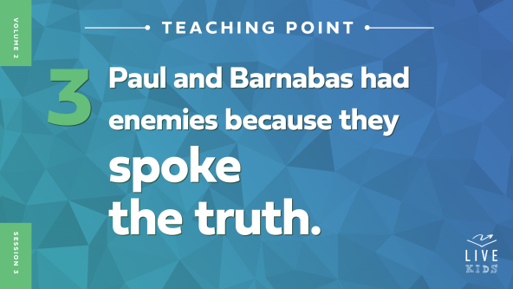

• *Read* [*Acts 14:19–20*](https://ref.ly/logosref/Bible.Ac14.19-20)*.*

Suddenly, Paul and Barnabas had another problem. Some other people got angry with Paul because of the truth he had been preaching.

Some of these Jews didn’t like what Paul was preaching. Remember, Paul was a Jew too, but he was speaking the truth that Jesus was the Messiah. And he was speaking the truth that people who weren’t Jews could be a part of God’s family.

Has there ever been a time you didn’t want someone else to speak the truth? *(Group response)* Sometimes people do strange or extreme things to keep the truth from being shared. These Jewish people were so mad that Paul was preaching about Jesus that they tried killing him right there in the street with the crowd!

Let’s imagine some situations when it would be hard to stand up for truth—but totally worth it! Remember in the video how Dash stuck up for someone when other people gossiped? Or maybe you’re playing sports and you tell the other team you stepped out of bounds or fouled someone. Maybe someone asks you what you think, and you tell the truth instead of saying what they want to hear.

Speaking the truth can be hard. Sometimes it can even make enemies for us! Look at Paul. People threw heavy rocks at him and tried to kill him. Then they dragged him outside the town. But even though he was hurt, he got up and went right back into the same town. Do you think Paul would say it’s always worth it to speak the truth? *(Group response)* I’m sure he would.

Speaking the truth is what God wants us all to do. Remember our Faith Fact today. **I will speak the truth**. When you speak the truth and stand up for it no matter what, people will notice you’re different. It will set you apart in a way that honors God.

**Prayer and Response**

*Consider playing a worship song softly in the background while kids pray.*

Speaking the truth is always the right thing to do, but it can be hard sometimes. It might keep us from winning a game or making friends with certain people. If we speak the truth to people who don’t like God’s truth, they might even think we are their enemy.

Today, we’re going to ask God, “What truth do I need to speak up about?” Maybe you need to be the real you at school, even if it means some people don’t want to hang out with you as much. Maybe you need to be brave enough to share your faith, even if people make fun of you. Maybe you need to tell your family the truth about a lie you’ve told or a secret you’re keeping.

We’re going to take some time to be quiet and pray about any area where we need to speak truth. Listen carefully to the thoughts in your mind and your heart. That is often how God speaks to us! After you know the truth God wants you to speak, consider sharing it with a friend or a leader around you who can help you pray about it.

• *Give kids a few minutes to hear from God.*

**Prayer**

*Optional: Have the kids repeat phrases of the prayer after you.*

|  |
| --- |
| *Dear God, thank You for always speaking the truth to me. Please help me speak the truth too—even when it could be easier to hide it. In Jesus’ name. Amen.* |

**Faith Verse**

Speaking the truth is one way we can be different from the world in the best way possible. But we know it’s not always easy. Our Faith Verse reminds us to let God change how we think so that we can be more like Him and less like the world!

• *Play* ***Faith Verse Video****.*

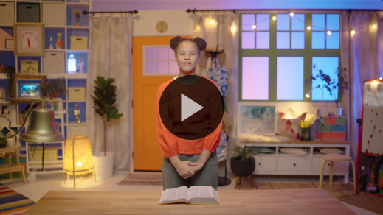

[Romans 12:2](https://ref.ly/logosref/Bible.Ro12.2) (NLT)

Don’t copy the behavior and customs of this world, but let God transform you into a new person by changing the way you think.

Let’s say that verse together in a high, squeaky mouse voice. *(Group response)* Now say it one more time with a low, growly grizzly bear voice! *(Group response)*

**Faith Fact**

Before we move on, let’s go over our Faith Fact again. **I will speak the truth.**

• *Show the* ***Faith Fact Slide****.*



Let’s say the Faith Fact together. **I will speak the truth** Point to yourself when you say “I” and point to your mouth when you say “speak.” Ready? **I will speak the truth.**

• *Dismiss kids to Small Group time or to go home if your group time ends here.*

**Small Group**

**30 Minutes**

*This section can be done in conjunction with the large group or on its own if you do small groups with your kids. During Small Group time, the goal is to connect the kids with the Word of God and to each other. All activities are led by the small group leader.*

**Group Connection**

|  |
| --- |
| *No prep is needed for this activit*y. |

**Never Have I Ever**

In our Bible story today, Paul and Barnabas showed us how important it is to speak the truth, no matter what. Some people couldn’t believe the truth Paul and Barnabas shared about God’s power. And others tried to hurt Paul because of it.

Today, let’s learn some more truths about each other through a game called Never Have I Ever. Here’s how it works. Everyone except the person who’s It will sit in a circle. The person who is It will stand in the center of the circle and say, “Never have I ever …” Then they will finish with something that they haven’t done before. For example, the person who’s It could say, “Never have I ever flown in an airplane. Have you?”

Then everyone else in the circle who *has* flown in an airplane gets up out of their seat and tries to find a new one. The person who’s It will also try to find a spot to sit in. Whoever can’t find a spot will get to be It for the next round.

• *Play until you run out of time.*

**Bible Lesson Recap**

• *If small group activities are not immediately following large group time, you may want to read the Bible story passage before the discussion.*

|  |
| --- |
| ***You Will Need***  *• Bibles for kids in the group to share*  *No prep is needed for this activity.* |

**Bible Story Review: Paul and Barnabas Confront Falsehood** [**Acts 14:8–20**](https://ref.ly/logosref/Bible.Ac14.8-20)

What was the most interesting thing about the Bible story we heard today? *(Allow responses.)* Those are great answers! To review, Paul and Barnabas chose to speak the truth, no matter what. They faced a couple of interesting situations because of their honesty. Do you remember what they were? *(Allow responses.)* Right! The people tried to worship them because they thought they were gods, and then people tried to kill Paul.

• *Optional: Give each kid a Bible and read the Bible story together.*

**Group Discussion**

*Feel free to use all or just a few questions as a jumping-off place for good discussion. Questions marked with * are designed for more conversation. Adjust the questions based on the age or maturity of your group. Typically, older kids will be able to dive a little deeper than younger ones.*

**Questions**

What happened that drew people’s attention to Paul and Barnabas?

What did the people who saw the miracle think about Paul and Barnabas? What did the people do?

What did Paul and Barnabas think about the people’s reaction? What did Paul and Barnabas do?

What did some the Jews think about this?

What happened to Paul after the Jews came?

* How do you think Paul and Barnabas felt about speaking the truth after this?

* When can it be hard for people to speak the truth?

* Can you share about a time when you spoke the truth even though it was hard? How about a time when you didn’t speak up because you were afraid?

* How does speaking the truth show others that we are different from the rest of the world?

**Live It**

|  |
| --- |
| *No prep is needed for this activity.* |

**Faith Fact**

Our Faith Fact today is **I will speak the truth.** The most important truth we could ever speak is the same one Paul and Barnabas likely shared—that Jesus is God’s Son and the only way to have eternal life!

Even though we know the truth, sometimes we can be afraid to speak it. Maybe it seems easier to hide it. Or maybe we think something could go wrong if we share it. But if we practice speaking the truth ahead of time, it can be easier to do it when the moment comes.

Today we’re going to practice speaking the truth to each other. Think about a truth about Jesus that you want to share with someone. Then tell it to our group.

• *Have kids take turns speaking the truth.*

**Challenge**

Your challenge is to speak this truth this week to someone who needs to hear it. This person could be a friend at school, a family member, or a new person you just met. Speak the truth God has put on your heart!

**Prayer**

*Finish group discussion by sharing prayer requests and praise reports. Keep track of your small group’s prayer requests and review them each time you meet.*

• *Have kids share and pray for each other’s prayer requests.*

|  |
| --- |
| *Dear God, thank You for being the One who is the truth and always speaks the truth. Please show us how we can speak the truth, even when it seems easier to hide it. In Jesus’ name. Amen.* |

**Faith Verse Review**

|  |
| --- |
| ***You Will Need***  *•* ***Small Group Faith Verse Review Page****, one set per team*  *• Scissors*  *• Optional: Smartphone to time activity*  ***Getting Ready***  *• Cut apart the slips from the* ***Small Group Faith Verse Review Page****.* |

Our Faith Verse is [Romans 12:2](https://ref.ly/logosref/Bible.Ro12.2). When we fill our mind with thoughts that honor God, our actions will please Him too. God can help us stop doing stuff that doesn’t honor Him or share His love. Let’s practice our Faith Verse.

• *Show* ***Faith Verse Video****.*



[Romans 12:2](https://ref.ly/logosref/Bible.Ro12.2) (NLT)

Don’t copy the behavior and customs of this world, but let God transform you into a new person by changing the way you think.

**Faith Verse Fun**

**Verse Shuffle**

All right, now it’s time to put our knowledge of the Faith Verse to the test. Let’s practice unscrambling it together. Pay attention, because after we do it once together, we’ll divide into teams and see which team can finish first.

• *Give kids the* ***Faith Verse Review*** *slips.*

• *Practice unscrambling the Faith Verse.*

• *Break into teams and let the teams race to unscramble the verse.*

• *Record the fastest times for the teams and declare a winner.*

Great job, everyone! Memorizing this Faith Verse will help transform your mind, which will help you speak the truth!

**Activity Page**

**Spot the Difference**

|  |
| --- |
| ***You Will Need***  *•* ***Small Group Activity Page****, one per kid*  *•* ***Small Group Activity Page Answer Page***  *• Pencils or pens, one per kid*  *• Crayons or markers*  ***Getting Ready***  *• Print copies of the* ***Small Group Activity Page****, one per kid.*  *• Print the* ***Small Group Activity Page Answer Page*** *if needed.* |

Our Faith Fact today is **I will speak the truth.** We talked about the way Paul and Barnabas did that in a difficult situation.

• *Hand out a copy of the* ***Small Group******Activity Page*** *a pencil, and crayons to each kid.*

See if you can spot the differences between these two pictures. Did you know that when we don’t speak the truth, differences and arguments can happen? We end up with stories or viewpoints that don’t match. So let’s practice finding these differences as quickly as we can!

**Dismissal**

Always remember that God wants us to be different from the rest of the world. When we follow Him, we are different in the best way possible!

**Prayer**

|  |
| --- |
| *Dear God, please help us to speak the truth, even when it might be easier to hide it. We want to know Your truth with the help of the Holy Spirit. Help us to follow Your truth no matter what. Amen.* |

**Faith Fact Recap**

• *Show the* ***Faith Fact Slide****.*



Remember, God doesn’t just want *me* or *someone else* to be different from the world. He wants *you* to stand out for Him in amazing ways too! Remembering the Faith Fact will help us do that. Say it with me one more time. **I will speak the truth.** I’m so glad you came today. I can’t wait to see you next time.

• *Send home the* ***Small Group Activity Page.***

• *Remind parents that there are* ***Family Devotions*** *available on the app to do with their kid.*

• *Tell everyone the date and time for the next session.*